**Teacher based resource**

**TEACHER SEN RESOURCES BOOK 20XX**

**Table of Content:**

**1. Continuum Explained**

**2. SEN Provision Map of support**

**3. Whole School Strategies 2018/2019**

**3a. Whole School Strategies 2019/2020**

**4. New Whole School Strategies 20XX**

**5. Support for all template (one for each group you teach)**

**6A. NEW SET planning template (for each SEN/Unit/TT group you have): Due end of Sept**

**6B. End of Term review of SEN classes taught (for each SEN/Unit/TT group you have): Due at Christmas, Easter and Summer**

**7. NEW SEN referral form**

**8. Level 1 and Level 2 and short courses**

**1. Contiuum of Support Explained**

[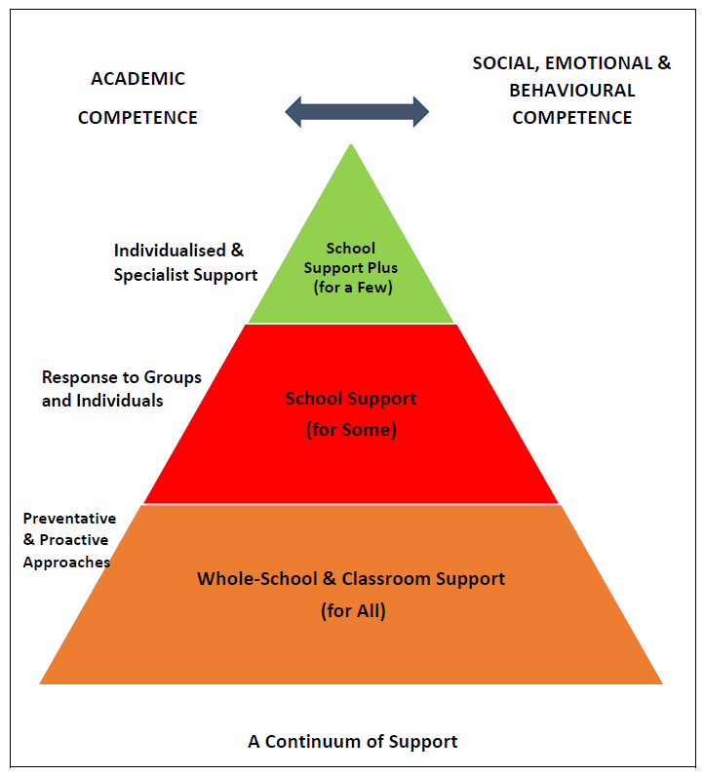](https://www.google.ie/url?sa=i&rct=j&q=&esrc=s&source=images&cd=&ved=2ahUKEwizrafVmarjAhXxmFwKHZTeBBoQjRx6BAgBEAU&url=https://www.sess.ie/special-education-teacher-allocation/primary/continuum-support-primary&psig=AOvVaw2-k4k4nBBvcWObapf-di7r&ust=1562842898590111)

**Impact of new SEN Model**

As a result of the new SEN model, XXX has decided to remove learning support and resource titles and replacing them with SET teachers. We allocate hours based on needs to pupils and groups. We employ team teaching, small group tuition and individual teaching as well as running our ASD classrooms.

**Support for ALL Students (100% of pupils)**

Under the new SEN continuum, all teachers are responsible for students with additional needs in our classroom. XXX has introduced school wide approached to support all pupils in the school. These are under the headings: Inclusion, Literacy, Numeracy and Organisational for 2018/2019 and new ones again this year 2019/20. These approaches aim to support and promote positive student behaviour and learning for all. ***(see forms No 3 and 4)***

Also for each class group each teacher must fill out a support for all assessment of need for their own SEN planning. ***(see form 5) (see form 7)***  
  
**Support for Some (10-20% of Students)**

Typically around 10-20% of the school population, who do not respond to the whole-school strategies sufficiently and who need more support. A range of approaches and interventions may be used, some of which may be short-term, while others may be longer term. These may include:

Mainstream teachers will contribute to student support files, help decide targets and aim to help the students through their teaching strategies to achieve such targets and help the SEN team to review Student Support Files. ***(see form 6A and 6B) (see form 7)***

**Support for a Few (2-3% of Students)**

These students, typically about 2-3% of the school population, have significant difficulties and may require intensive, individualised interventions. Interventions at this stage are likely to include:

Individual Learning Plans (including behavioural plans) ***(see form 6A and 6B) (see form 7)***

**Roles and Responsibilities**

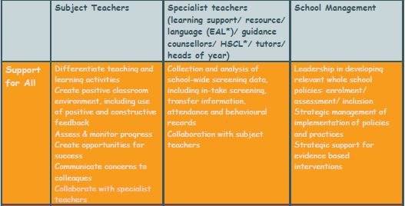

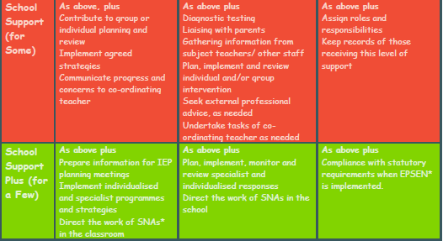

**2. Provision Map of XXXXXXXXX**

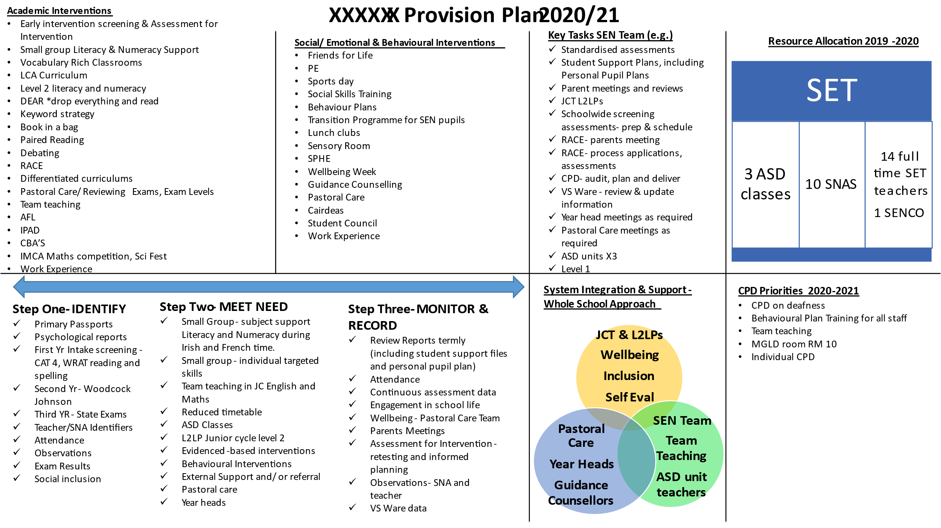

**3. Whole School Strategies: School Year 2018/2019 (ALL STILL APPLY THIS YEAR)**

**Literacy:** A keyword copy is used for all JC students with 10 key words from each topic named and explained in their own words for each subject.

**Numeracy:**

Pupils will estimate % and then calculate their own %’s on tests, based on mark given.

Formula to be used by all teachers:

Mark divided by total of test multiplied by 100 =

**Inclusion:** All pupils are welcome into mainstream classes and subject teachers will differentiated down to their level eg JC Level 2. In XXX we welcome our ASD unit pupils and MGLD pupils into all mainstream classes.

**Organisational:**

Best practice white board layout will be used:

o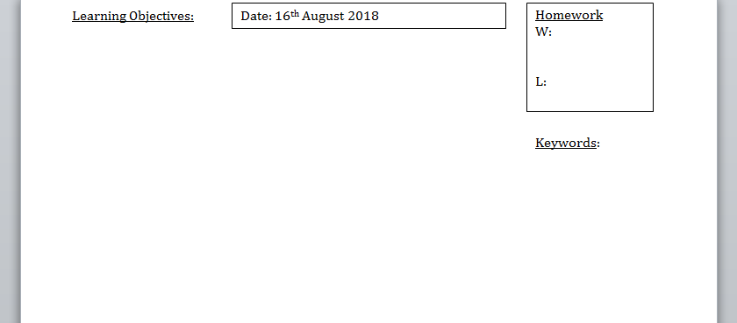

**3A. Whole School Strategies: School Year 2019/2020 (STILL APPLIES THIS YEAR)**

**Literacy:**

A keyword list AT THE BACK OF EVERY HARD BACK COPY (IPAD) is used for all JC students with 10 key words from each topic named and explained in their own words for each subject.

**Numeracy:**

To explicitly teach the analogue/ digital time at every teaching opportunity that presents including: AM, PM, 24 hour clock, Add and subtracting time, stop watches etc

**Inclusion:**

All pupils are welcome into mainstream classes and subject teachers will differentiated down to their level eg JC Level 2. In XXXX we welcome our ASD unit pupils and MGLD pupils into all mainstream classes. We will also this year encourage and arrange extra curricular opportunities for you pupils with SEN.

**Organisational:**

Best practice white board layout will be continued.

**4. Whole School Strategies: School Year 2020/2021**

**Literacy:**

**Numeracy:**

**Inclusion:**

**Organisational:**

Best practice white board layout will be continued.

**Behavioural:**

**Form 5. Support for All: Class Assessment of Need (one to used per class group you teach, for your own planning and SEN Target setting)**

Class:

|  |  |  |  |
| --- | --- | --- | --- |
| Initials | Need (SEN) | Targets | Strategy |
|  |  |  |  |
|  |  |  |  |
|  |  |  |  |
|  |  |  |  |
|  |  |  |  |
|  |  |  |  |
|  |  |  |  |

**Form 5. Support for All: Class Assessment of Need (one to used per class group you teach, for your own planning and SEN Target setting)  SAMPLE A School has Made**

|  |  |  |  |
| --- | --- | --- | --- |
| **INIT**  **IALS** | **NEED (AEN)** | **TARGETS** | **STRATEGY** |
|  | SLD Dyslexia  Reading, spelling, reading comprehension,  Poor reading age | X will engage in pair work or groupwork once a week in class.  X will answer an oral question at least once a week in class.  X will read from a power point following pre teaching of key words in a revision class.  X will independently record homework in all lessons  X will proficient touch type 25 words per minute using ttrs/typing.com | * Allow 10-12 seconds wait time for an answer. * Allow extra time to complete classwork work. * Use of graphic organiser * Provide opportunities for small groupwork such as Think Pair Share/Pair work or group work * Photocopy notes so student does not have to copy from the board. * Send notes on TEAMS so student does not have to copy from the board. * Carry a toolkit with a spare pen and pencil. Dyslexic students can be forgetful. * Use of colour coded timetable. * Use of checklists. * Employ visual stimuli such as power points of educational you tube clips. * Praise the effort and focus on what has been achieved rather than the result. * When devising worksheets or assessments. use the comic sans font. * Encourage use of a book mark for following if a teacher/students is reading from a a text book. * Negotiate with the pupil when they read in class. * Use of mnemonics device as a memory aid. * www.mnemonic-device.com * Proficiently touch-type 15/30 words per minute * Use the Onenote read aloud software to listen to their texts * Use the Look, Cover, Say, Write, Check method with new spellings * Read and spell the 300 most frequently used words in the English language (Stareway to Spelling or SNIP) * (Through cloze exercises), predict and infer from texts. * Use an electronic dictionary and thesaurus. * Identify with subject-specific word vocabulary * Mind-map key concepts in different subjects, to help organise, plan and structure written tasks. * Identify with social-sight vocabulary * Expand their vocabulary, using synonyms and antonyms. * Extract the key words from a piece of text. * Summarise the main point in a text. * Use capital letters and full stops. * Use commas. * Vary their choice of verbs in piece of writing. * Vary their choice of adjective in a piece of writing. * Retrieve information from a text. * Brainstorm ideas * Develop a list of keywords/images/mind-maps to structure ideas * Plan a piece of free writing * Read and retell a simple story from books and from everyday experience, to include a beginning, middle and end * Recognise the features of a short story. * Identify the nouns, verbs and adjectives in a text * Predict what happens in a story * Read independently for a variety of purposes * Use the internet as a source for information * Differentiate between different genres, e.g. article, speech, fiction, drama etc * Identify and state the function of literary techniques e.g. poetic techniques * Retell a story * Draw conclusions/predict what will happen from a text * Use the PQE/PEE technique * Recognise persuasive language * Review a short text * Recite a poem * Identify themes * Write a blurb for their favourite book * Self-correct * Skim and scan a piece of text * Form an opinion on a piece of text * Compare and contrast two pieces of text * Keep a reflective journal * **Read for 10 minutes per day** * Develop a topic sentence into a paragraph * Use a paragraph * Vary sentence structure * Edit vocabulary to make it more appealing * Select appropriate language when writing a text * Brainstorm activities - groupwork |
|
|  | Anxiety | X will use regulation strategy pre discussed with student and reviewed weekly after lessons taught | * Praise the effort. * Use of VS ware merit system to reward good effort. * Use of breathing techniques Dot B * structure classroom activities and small groups so anxious students are not left out * Allow students to select their own partner(s) for group-based assignments * Assign a classroom buddy to provide support |
|  | ASD | X will use regulation strategy pre discussed with student and reviewed weekly after lessons taught  X will engage in pair work or groupwork once a week in class.  X will take one less movement breaks weekly  X will take one extra movement break weekly  X will use colour coded timetable on door to work on work on bringing correct materials to class daily | * Seat the student in a position clear from distractions. * Situate the student for optimal attention to instruction and/or sensory needs. * Give short clear instructions. * Provide regular reinforcement of behaviour using VS Ware merits system. * Off the opportunity to work in pairs or small groups. * Teach understanding and acceptance in the classroom. * Use of social stories to explain what might happen in a particular situation. * The environment is orderly and not  cluttered so that service users can  make sense of the environment. * The impact of wall displays, and  visuals is considered. * Audio systems, computers, lights  and visual displays are switched off  when not in use to avoid a mass  humming noise. * Speakers are not especially loud in  their noise level and pitch. Use only  when necessary. * Are there particular sounds which  may irritate hypersensitive * individuals? (e.g., clocks ticking,  bells, lights humming, road noises,  etc.) * Clear visual warnings are in place  informing people of an alarm, and  why and when it may go off. * Be aware of the volume and pitch  of speakers in your workplace. Are  they all at a standard volume? Is it  too loud? * Do not immediately chastise or yell  at an autistic person if they are  stimming or exhibiting challenging  behaviour. Establish the cause and  deal with it calmly in a level tone. |
|  | ADD/ADHD | X will use regulation strategy pre discussed with student and reviewed weekly after lessons taught  X will use colour coded timetable on door to work on work on bringing correct materials to class daily  X will take one extra movement break weekly | * Use of a timer to maintain focus. * Seat the student in a quiet area close to a positive role model. * Be clear and concise with instructions. * Check in with the student and ask if she/he understands the expectations. * Include a variety of activities. * Allow a short (2-3 minute) movement break. This may involve running an errand. * Incorporating planned ‘movement breaks’ within lesson plans is an effective way of ‘feeding’ the * students’ sensory systems and maintaining their levels of alertness. * identify a quiet place (e.g., a restroom, NURTURE ROOM hallway, or AEN office) where a student can go if they feel overwhelmed * Use of a bookmark to allow student to remain on task * Ignore minor inappropriate behaviour, comments and questions. * Use of VS Ware to reward positive behaviour. |
|  | COMMUNICATION DIFFICULTIES | X will ask 1 question in every exam subject class  X will log and record questions from class and bring to SET for answering | * Gain attention before issuing instructions/homework – call by name * Keep instructions short, provide a context. Explicit instruction suits best. * Discuss with student to practise silent repeat of the instruction * Use visual supports alongside the spoken language * Repeat and write instructions down * Explain what the class is learning, why they are learning it and how they will know that they have learned it * Use graphic organisers |
|  | ORGANISATION | X will use colour coded timetable on door to work on work on bringing correct materials to class daily  X will check for understanding at the end of each class prior to leaving classroom | * Have a spare textbook * Have a spare copybook * Provide handout – keep handout folder in the event student comes to class without it * Discuss goals, targets, expectations * Colour coding of books and copies may help the student with the organisation of school books. * Seat at front. * Beside 2 role models * Close proximity for oral instruction. * Good eye contact - where possible * Check for understanding...repeat the instruction * Short activities and short movement breaks. * Sensory object - fidget/blue tac |
|  | DCD | X will bring the correct books to class 4 out of 5 times by January.  X will create one mindmap per week based on a topic taught in X class. | * Organise his bag so that he has the correct books for each class. * Read his/her timetable and locate each room in the school building. * Follow instructions for group tasks. * Successfully take down homework from the board. * Proficiently touch-type 15 words per minute. * Mind-map key concepts in different subjects * Make use of colour, bullet-points, margins, headings, diagrams and illustrations when making notes. * Summarise a piece of text. * Apply the LCSWC when learning to spell. * Make use of colour, bullet points, margins, headings, diagrams and illustrations when making notes. * Retell, summarise and paraphrase both a written and oral piece of work |
|
|
|
|
|
|
|
|
|
|
|
|
|
|
|
|  | CHALLENGING BEHAVIOURS | X will follow teacher’s one-step instructions agreeably at least twice in every class.  X will remain quiet when others are speaking for 30 minutes of the forty in X class.  If X has a query/statement, they will raise their hand to get teacher’s attention in class. | * Positive language only * Clear, short specific instructions * Praise and encouragement at all times * Clean slate approach daily * Supply equipment/materials for class * Mindfullness sheets when disengaged - learn by listening * Use name |

***Form 6A. SET Planning Form (for each SEN group you have, mainstream or unit), to be handed up at the end of Sept each year.***

|  |  |
| --- | --- |
| Teacher/s: |  |
| Type of SEN Support | Indivudal Support  Group Support  ASD class  Team teaching |
| List of Students: | Use initials to protect pupils |
| Timetable (Days, times and  location): |  |
| Overall Subject/Topic: |  |
| Learning outcomes: |  |
| Student Activities: |  |
| Teaching strategies: |  |
| Resources: |  |
| Assessments: (formal and informal) |  |

**End of Term Form 6B. Review of SEN classes (log each term)**

**Check List:**

1. I have read these pupils recommendations from their reports.

2. I read these pupils student support file (will be ready in late September)

-----------------------------------------------------------------------------------------------

**What was covered this term: **teachers responsibility to hold evidence of learning outcomes achieved\*\***

|  |  |  |  |
| --- | --- | --- | --- |
| **Date** | **Topic** | **Outcome** | **Notes** |
|  |  |  |  |
|  |  |  |  |
|  |  |  |  |
|  |  |  |  |
|  |  |  |  |
|  |  |  |  |
|  |  |  |  |
|  |  |  |  |
|  |  |  |  |

**Form 7: Confidential SEN Referral Form 2019/2020**

Student Name: Class Group:

Referred by: Date of Referral:

**Issue:** Please tick:

Academic  Reading Writing Spelling Other

Organisation Emotional Behaviour Attendance

**Fill out CAT 4 score (found under notes VSware):**

**Have they a student support file (under SEN on vsware): Yes No   
Are their targets in their file meeting this issue:**

**If issue around writing a sample of 250 words to be provided.**

**Additional Information:**

**What would you like the Sen dept to do?**

**Office Use Only:**

Date received: Received By: Action Taken by: ___________________

**Form 8. Level 1 and 2 Teachers Booklet**

* JC Level 1 and 2 can be combined with JC level 3 subjects.
* If you are sharing a subject with another teacher, then you need to meet and decide who is covering which of the learning outcomes.
* Evidence must be kept of each learning outcome in their folders, I recommend that you as the teacher keep the folder so support evidence gathering. To achieve a level 2 accreditation in subject pupils must achieve 50% +1 of the learning outcomes of each subject over three years.
* This appears on their JCPA in the November after their results. The school will issues Level 1 / 2 school certificates on the day of JC results so as they feel included if this is their only results they will be achieving.
* Resources are avail in room 10 and room 11 and if there is anything else you need please ask.
* I will email you a booklet on one drive it is your scheme of work and you need to fill this in as elements are achieved and keep evidence of all their copies and work done. We will hold a SLAR Meeting next April on accreditation of pupils.
* Short Courses must have 1 CBA this year and criteria must be set out and a SLAR in April.

**Level 1**

|  |  |  |
| --- | --- | --- |
| Student | Subject | Teacher(s) Responsible |
| N/a |  |  |
|  |  |  |

**First Year Level 2**

|  |  |  |
| --- | --- | --- |
| Student | Subject | Teacher(s) Responsible |
|  | Literacy, numeracy |  |
|  | Literacy, numeracy |  |
|  | Literacy, Numeracy |  |

**Second Year Level 2**

|  |  |  |
| --- | --- | --- |
| Student | Subject | Teacher(s) Responsible |
|  | Literacy, numeracy |  |
|  | Literacy, numeracy |  |

**Third Year Level 1/2**

|  |  |  |
| --- | --- | --- |
| Student | Subject | Teacher(s) Responsible |
|  | Literacy |  |
|  | Numeracy |  |

**Short Courses**

|  |  |  |
| --- | --- | --- |
| **Student** | **Subject** | **Teacher(s) responsible** |
| 1st year: |  |  |
| 2nd Year: |  |  |
| 3rd Year | Caring for Animals |  |

Form 9 Summary of main SEN in XXX are:

**ASD**

Three main difficulties:  
Social, Sensory, Emotional difficulties

Lack of empathy   
Lack flexibility of thinking  
Takes things literally eg raining cats and dogs

IQ can vary

Things that can help:  
Now and then, giving choices  
Visual instructions on whiteboard  
Breaks as needed   
Calm voice   
Easy social interactions like structured group work

**Tic Disorder**: sudden and rapid body movements, occurs more when stressed. Don’t point it out and try remove stressors

**ADHD:** often avg and above avg IQ

Three features/difficulties:

Poor attention span  
Fidgets, restless  
Talk excessively   
Rush into things

Things that can help:  
Clutter free desk, placement at front of room.  
Have their eye contact and attention before issuing 1 or 2 step instructions  
Break down tasks into small achievable chunks  
Not bold: calm responses to perceived not paying attention

**DCD:** Developmental Co-ordination Disorder (Avg to High IQ)

Three difficulties:  
Poor motor skills appear clumsy, doing buttons, forgetful, PE, Wood, Cooking, DCG issues.   
Difficult co-ordinating thoughts: essay planning  
Poor spacial awareness  
**Poor handwriting**, can’t grip pen properly, graphing, drawing.

Two things that help:  
Typed notes**, ipad to give notes, shouldn’t be taking notes, no benefit**

Written instructions on whiteboard: break down bigger tasks into small tasks  
One step instructions

**Dyslexia:**

Three difficulties:

Writing quality and speed, reading rate, fluency, and accuracy. Spelling  
Avg + IQ but doesn’t match their literacy capabilities. Oral does not match written.   
Not able to copy from whiteboard

Two things that can help:  
Ipad or typed notes, wasting time writing it won’t help  
Fonts: Dyslexie, Comic Sans, give notes and powerpoints in word so that they can edit them as they find a font that works.   
Caution re reading aloud.

**Dyscalculia (Avg to High IQ)**

Three difficulties:

Maths poor despite intervention: operations, estimating, generalising  
Find remember directions and locations  
Avg IQ+  
Things that can help:  
Hands on maths real life example  
Find out are they visual or written or auditory learners  
One step of sum at a time.   
Limited writing from board, don’t take it down right, graphing.

**EBD: Emotional Behavioural Disorder**

Three difficulties:   
Low self-esteem  
Find group work hard   
Aggression refusal to work/co-operate

Two things that work:   
Forming a positive relationship with adults they can trust.   
Positive reinforcement   
“catch them being good”  
Calm voice and tone

**MGLD: Mild or Moderate General Learning Difficulty**

Below average IQ   
Reducing learning capabilities   
Can’t generalise   
Poor retention ability

Things that help:   
Differentiation Downwards (FL, level 2, primary)  
Supportive relationship  
One step instruction, use whiteboard

**ODD: Opposition Defiance Disorder**

Three difficulties:   
Argues with adults/peers  
Deliberately annoys people  
Blames others  
Defies and pushes boundaries

Things that help:  
Whilst seems deliberate they cant help it, try find empathy  
Placement near a better role model  
Consistent in rules, rewards and sanctions, Catch being good